1.

a
*Baran a
.MODEL MOSN NMOS LEVEL=2 LD=0.15U TOX=200.0E-10
+ NSUB=5.36726E+15 VTO=0.743469 KP=8.00059E-05 GAMMA=0.543
+ PHI=0.6 U0=655.881 UEXP=0.157282 UCRIT=31443.8
+ DELTA=2.39824 VMAX=55260.9 XJ=0.25U LAMBDA=0.0367072
+ NFS=1E+12 NEFF=1.001 NSS=1E+11 TPG=1.0 RSH=70.00
+ CGDO=4.3E-10 CGSO=4.3E-10 CJ=0.0003 MJ=0.6585
+ CJSW=8.0E-10 MJSW=0.2402 PB=0.58

*eleman bağlantıları

VDD 3 0 DC 3.1
R1 3 2 100K
VIN 1 0 pulse (0 3.1 0 1n 1n 5n 10n)

M1 2 1 0 0 MOSN W=1.8u L=1.2u NRS=0.333 NRD=0.333
+ AD=6.5p PD=9.0u AS=6.5p PS=9.0u
C1 2 0 1f
.control
dc VIN 0 3.1 0.01
plot V(2) vs V(1)
.endc
.end
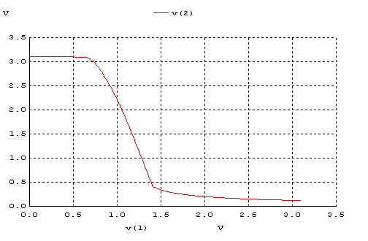

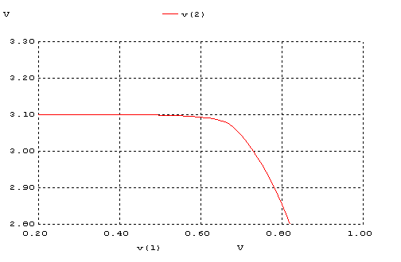
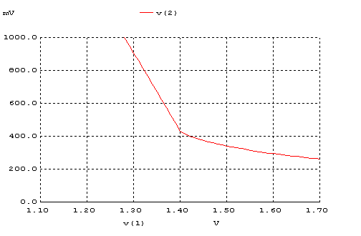

b.
*Baran b
.MODEL MOSN NMOS LEVEL=2 LD=0.15U TOX=200.0E-10
+ NSUB=5.36726E+15 VTO=0.743469 KP=8.00059E-05 GAMMA=0.543
+ PHI=0.6 U0=655.881 UEXP=0.157282 UCRIT=31443.8
+ DELTA=2.39824 VMAX=55260.9 XJ=0.25U LAMBDA=0.0367072
+ NFS=1E+12 NEFF=1.001 NSS=1E+11 TPG=1.0 RSH=70.00
+ CGDO=4.3E-10 CGSO=4.3E-10 CJ=0.0003 MJ=0.6585
+ CJSW=8.0E-10 MJSW=0.2402 PB=0.58

.MODEL MOSP PMOS LEVEL=2 LD=0.15U TOX=200.0E-10
+ NSUB=4.3318E+15 VTO=-0.738861 KP=2.70E-05 GAMMA=0.58
+ PHI=0.6 U0=261.977 UEXP=0.323932 UCRIT=65719.8
+ DELTA=1.79192 VMAX=25694 XJ=0.25U LAMBDA=0.0612279
+ NFS=1E+12 NEFF=1.001 NSS=1E+11 TPG=-1.0 RSH=120.6
+ CGDO=4.3E-10 CGSO=4.3E-10 CJ=0.0005 MJ=0.5052
+ CJSW=1.349E-10 MJSW=0.2417 PB=0.64

*eleman bağlantıları

VDD 3 0 DC 3.1
VIN 1 0 pulse (0 3.1 0 1n 1n 5n 10n)

M1 2 0 3 3 MOSP W=1.8u L=1.2u NRS=0.333 NRD=0.333
+ AD=6.5p PD=9.0u AS=6.5p PS=9.0u

M2 2 1 0 0 MOSN W=1.8u L=1.2u NRS=0.333 NRD=0.333
+ AD=6.5p PD=9.0u AS=6.5p PS=9.0u
C1 2 0 1f
.control
dc VIN 0 3.1 0.01
plot V(2) vs V(1)
.endc
.end

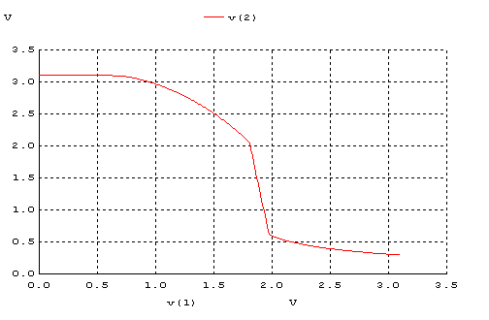
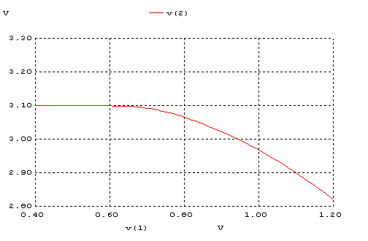
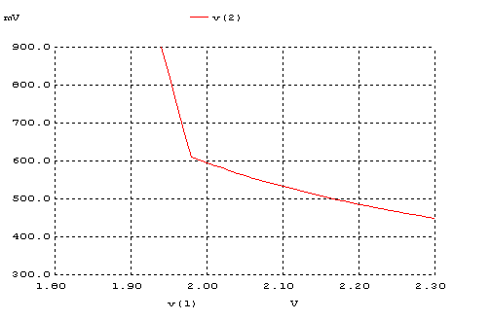

c.
*baran c

.MODEL MOSP PMOS LEVEL=2 LD=0.15U TOX=200.0E-10
+ NSUB=4.3318E+15 VTO=-0.738861 KP=2.70E-05 GAMMA=0.58
+ PHI=0.6 U0=261.977 UEXP=0.323932 UCRIT=65719.8
+ DELTA=1.79192 VMAX=25694 XJ=0.25U LAMBDA=0.0612279
+ NFS=1E+12 NEFF=1.001 NSS=1E+11 TPG=-1.0 RSH=120.6
+ CGDO=4.3E-10 CGSO=4.3E-10 CJ=0.0005 MJ=0.5052
+ CJSW=1.349E-10 MJSW=0.2417 PB=0.64

*eleman bağlantıları

VDD 3 0 DC 3.1
VIN 1 0 pulse (0 3.1 0 1n 1n 5n 10n)

M1 2 1 3 3 MOSP W=1.8u L=1.2u NRS=0.333 NRD=0.333
+ AD=6.5p PD=9.0u AS=6.5p PS=9.0u
C1 2 0 1f
R1 2 0 100K
.control
dc VIN 0 3.1 0.01
plot V(2) vs V(1)
.endc
.end

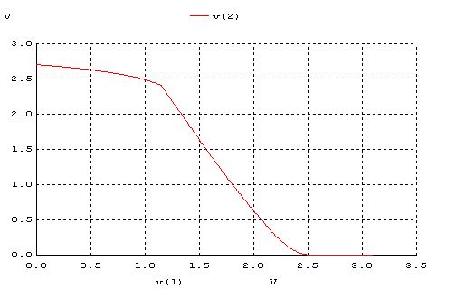
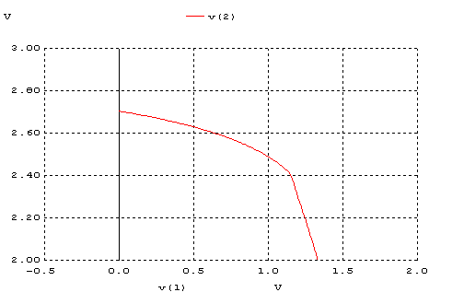
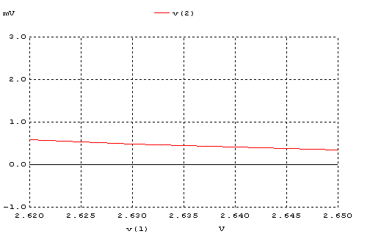

d.
*baran d
.MODEL MOSN NMOS LEVEL=2 LD=0.15U TOX=200.0E-10
+ NSUB=5.36726E+15 VTO=0.743469 KP=8.00059E-05 GAMMA=0.543
+ PHI=0.6 U0=655.881 UEXP=0.157282 UCRIT=31443.8
+ DELTA=2.39824 VMAX=55260.9 XJ=0.25U LAMBDA=0.0367072
+ NFS=1E+12 NEFF=1.001 NSS=1E+11 TPG=1.0 RSH=70.00
+ CGDO=4.3E-10 CGSO=4.3E-10 CJ=0.0003 MJ=0.6585
+ CJSW=8.0E-10 MJSW=0.2402 PB=0.58

.MODEL MOSP PMOS LEVEL=2 LD=0.15U TOX=200.0E-10
+ NSUB=4.3318E+15 VTO=-0.738861 KP=2.70E-05 GAMMA=0.58
+ PHI=0.6 U0=261.977 UEXP=0.323932 UCRIT=65719.8
+ DELTA=1.79192 VMAX=25694 XJ=0.25U LAMBDA=0.0612279
+ NFS=1E+12 NEFF=1.001 NSS=1E+11 TPG=-1.0 RSH=120.6
+ CGDO=4.3E-10 CGSO=4.3E-10 CJ=0.0005 MJ=0.5052
+ CJSW=1.349E-10 MJSW=0.2417 PB=0.64

*eleman bağlantıları

VDD 3 0 DC 3.1
VIN 1 0 pulse (0 3.1 0 1n 1n 5n 10n)

M1 2 1 3 3 MOSP W=1.8u L=1.2u NRS=0.333 NRD=0.333
+ AD=6.5p PD=9.0u AS=6.5p PS=9.0u

M2 2 1 0 0 MOSN W=1.8u L=1.2u NRS=0.333 NRD=0.333
+ AD=6.5p PD=9.0u AS=6.5p PS=9.0u
C1 2 0 1f
.control
dc VIN 0 3.1 0.01
plot V(2) vs V(1)
.endc
.end

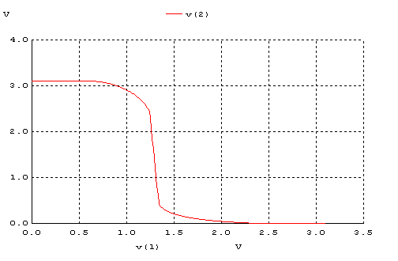
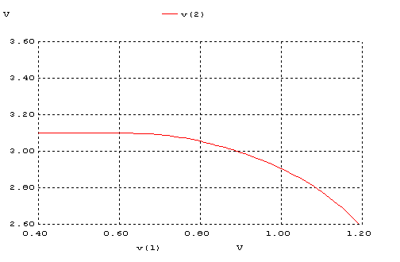
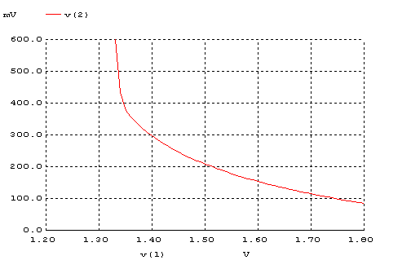

2.
a
*bara-transient a
.MODEL MOSN NMOS LEVEL=2 LD=0.15U TOX=200.0E-10
+ NSUB=5.36726E+15 VTO=0.743469 KP=8.00059E-05 GAMMA=0.543
+ PHI=0.6 U0=655.881 UEXP=0.157282 UCRIT=31443.8
+ DELTA=2.39824 VMAX=55260.9 XJ=0.25U LAMBDA=0.0367072
+ NFS=1E+12 NEFF=1.001 NSS=1E+11 TPG=1.0 RSH=70.00
+ CGDO=4.3E-10 CGSO=4.3E-10 CJ=0.0003 MJ=0.6585
+ CJSW=8.0E-10 MJSW=0.2402 PB=0.58

*eleman bağlantıları

VDD 3 0 DC 3.1
R1 3 2 100K
VIN 1 0 pulse (0 3.1 0 1n 1n 5n 10n)

M1 2 1 0 0 MOSN W=1.8u L=1.2u NRS=0.333 NRD=0.333
+ AD=6.5p PD=9.0u AS=6.5p PS=9.0u
C1 2 0 1f
.control
tran 1p 20ns
plot V(2) V(1)
.endc
.end

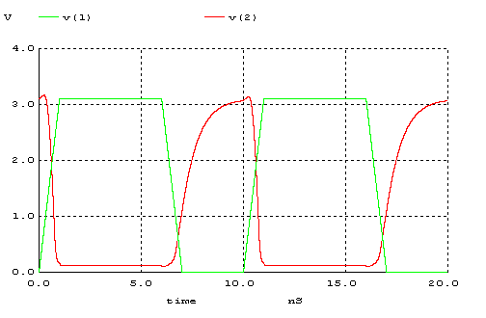

tpHL
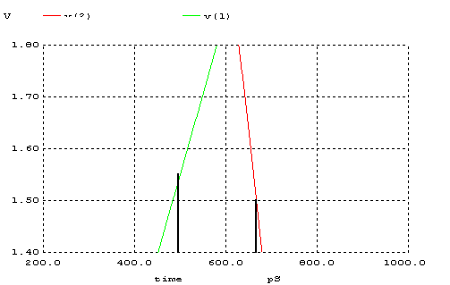
tpLH
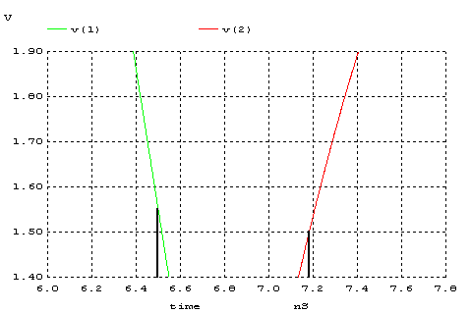

tf

%90
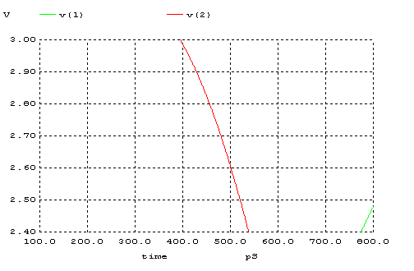
%10
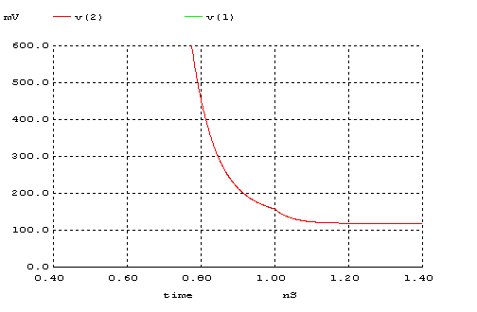
tr
%90
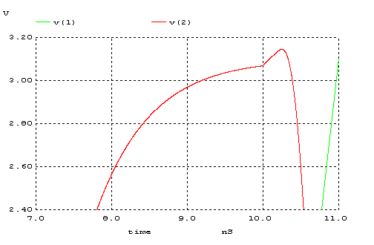
%10
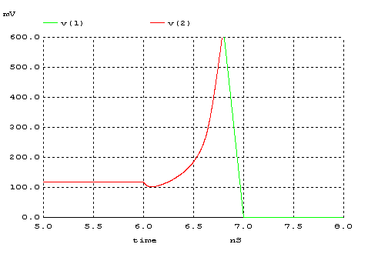

b.
*baran-transient b
.MODEL MOSN NMOS LEVEL=2 LD=0.15U TOX=200.0E-10
+ NSUB=5.36726E+15 VTO=0.743469 KP=8.00059E-05 GAMMA=0.543
+ PHI=0.6 U0=655.881 UEXP=0.157282 UCRIT=31443.8
+ DELTA=2.39824 VMAX=55260.9 XJ=0.25U LAMBDA=0.0367072
+ NFS=1E+12 NEFF=1.001 NSS=1E+11 TPG=1.0 RSH=70.00
+ CGDO=4.3E-10 CGSO=4.3E-10 CJ=0.0003 MJ=0.6585
+ CJSW=8.0E-10 MJSW=0.2402 PB=0.58

.MODEL MOSP PMOS LEVEL=2 LD=0.15U TOX=200.0E-10
+ NSUB=4.3318E+15 VTO=-0.738861 KP=2.70E-05 GAMMA=0.58
+ PHI=0.6 U0=261.977 UEXP=0.323932 UCRIT=65719.8
+ DELTA=1.79192 VMAX=25694 XJ=0.25U LAMBDA=0.0612279
+ NFS=1E+12 NEFF=1.001 NSS=1E+11 TPG=-1.0 RSH=120.6
+ CGDO=4.3E-10 CGSO=4.3E-10 CJ=0.0005 MJ=0.5052
+ CJSW=1.349E-10 MJSW=0.2417 PB=0.64

VDD 3 0 DC 3.1
VIN 1 0 pulse (0 3.1 0 1n 1n 5n 10n)

M1 2 0 3 3 MOSP W=1.8u L=1.2u NRS=0.333 NRD=0.333
+ AD=6.5p PD=9.0u AS=6.5p PS=9.0u

M2 2 1 0 0 MOSN W=1.8u L=1.2u NRS=0.333 NRD=0.333
+ AD=6.5p PD=9.0u AS=6.5p PS=9.0u
C1 2 0 1f
.control
tran 1p 20ns
plot V(2) V(1)
.endc
.end

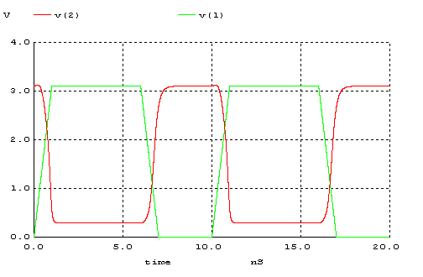
tpHL
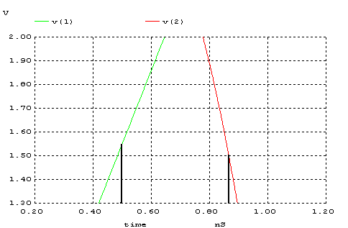

tpLH
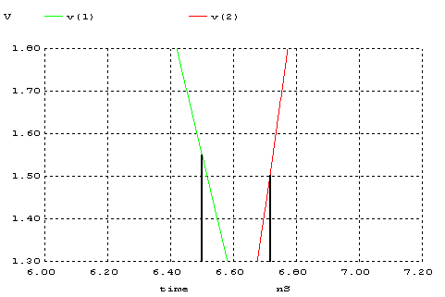

tf
%90
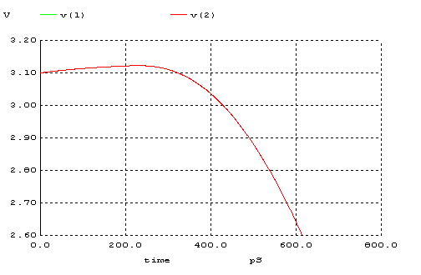
%10
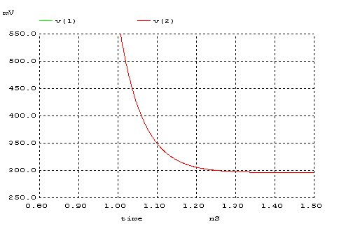
tr
%90
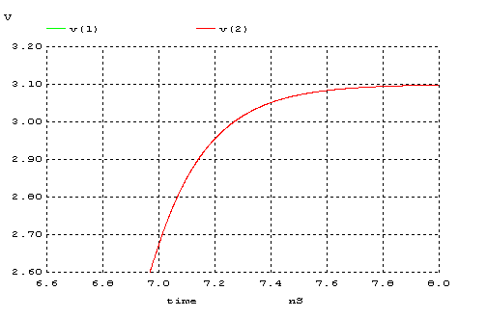
%10
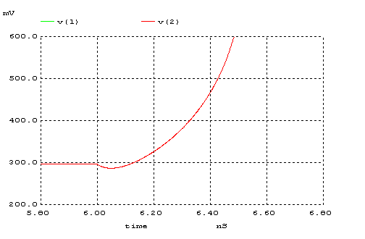
c.
*baran-transient c

.MODEL MOSP PMOS LEVEL=2 LD=0.15U TOX=200.0E-10
+ NSUB=4.3318E+15 VTO=-0.738861 KP=2.70E-05 GAMMA=0.58
+ PHI=0.6 U0=261.977 UEXP=0.323932 UCRIT=65719.8
+ DELTA=1.79192 VMAX=25694 XJ=0.25U LAMBDA=0.0612279
+ NFS=1E+12 NEFF=1.001 NSS=1E+11 TPG=-1.0 RSH=120.6
+ CGDO=4.3E-10 CGSO=4.3E-10 CJ=0.0005 MJ=0.5052
+ CJSW=1.349E-10 MJSW=0.2417 PB=0.64

*eleman bağlantıları

VDD 3 0 DC 3.1
VIN 1 0 pulse (0 3.1 0 1n 1n 5n 10n)

M1 2 1 3 3 MOSP W=1.8u L=1.2u NRS=0.333 NRD=0.333
+ AD=6.5p PD=9.0u AS=6.5p PS=9.0u
C1 2 0 1f
R1 2 0 100K
.control
tran 1p 20ns
plot V(2) V(1)
.endc
.end

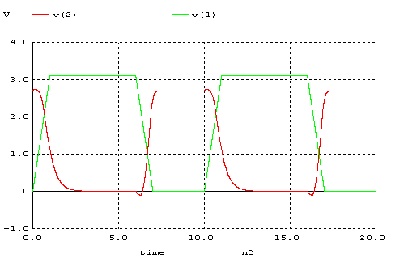
tpHL
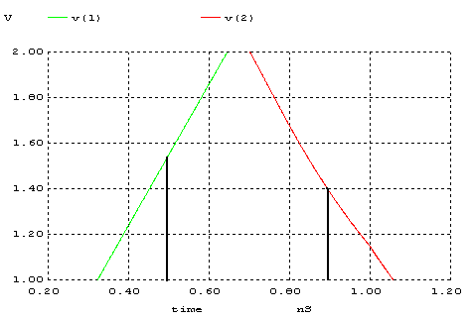

tpLH
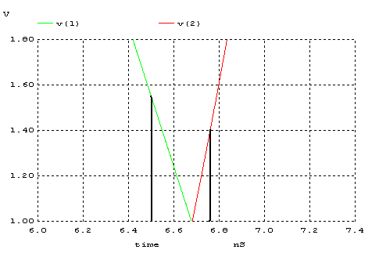
tr
%90
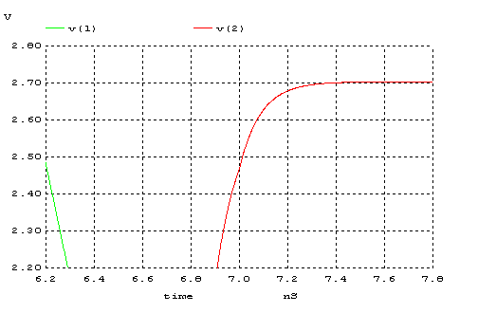
%10
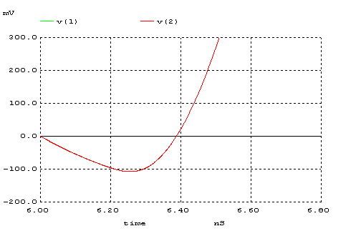
tf
%90
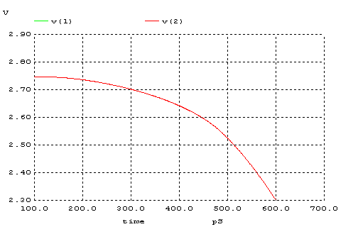
%10
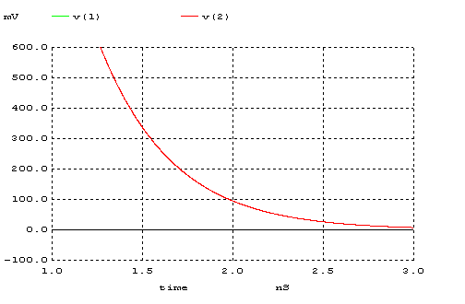
d.
*baran-transient d
.MODEL MOSN NMOS LEVEL=2 LD=0.15U TOX=200.0E-10
+ NSUB=5.36726E+15 VTO=0.743469 KP=8.00059E-05 GAMMA=0.543
+ PHI=0.6 U0=655.881 UEXP=0.157282 UCRIT=31443.8
+ DELTA=2.39824 VMAX=55260.9 XJ=0.25U LAMBDA=0.0367072
+ NFS=1E+12 NEFF=1.001 NSS=1E+11 TPG=1.0 RSH=70.00
+ CGDO=4.3E-10 CGSO=4.3E-10 CJ=0.0003 MJ=0.6585
+ CJSW=8.0E-10 MJSW=0.2402 PB=0.58

.MODEL MOSP PMOS LEVEL=2 LD=0.15U TOX=200.0E-10
+ NSUB=4.3318E+15 VTO=-0.738861 KP=2.70E-05 GAMMA=0.58
+ PHI=0.6 U0=261.977 UEXP=0.323932 UCRIT=65719.8
+ DELTA=1.79192 VMAX=25694 XJ=0.25U LAMBDA=0.0612279
+ NFS=1E+12 NEFF=1.001 NSS=1E+11 TPG=-1.0 RSH=120.6
+ CGDO=4.3E-10 CGSO=4.3E-10 CJ=0.0005 MJ=0.5052
+ CJSW=1.349E-10 MJSW=0.2417 PB=0.64

*eleman bağlantıları

VDD 3 0 DC 3.1
VIN 1 0 pulse (0 3.1 0 1n 1n 5n 10n)

M1 2 1 3 3 MOSP W=1.8u L=1.2u NRS=0.333 NRD=0.333
+ AD=6.5p PD=9.0u AS=6.5p PS=9.0u

M2 2 1 0 0 MOSN W=1.8u L=1.2u NRS=0.333 NRD=0.333
+ AD=6.5p PD=9.0u AS=6.5p PS=9.0u
C1 2 0 1f
.control
tran 1p 20ns
plot V(2) V(1)
.endc
.end

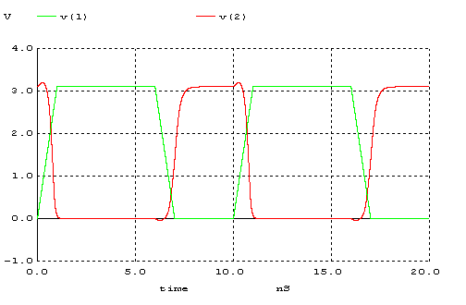
tpHL
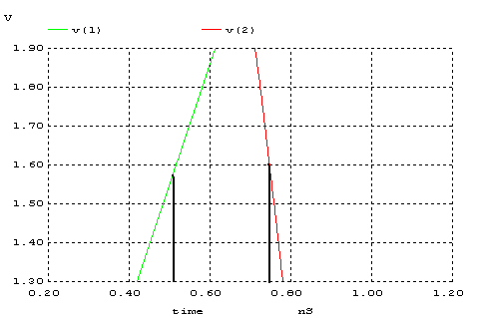
tpLH
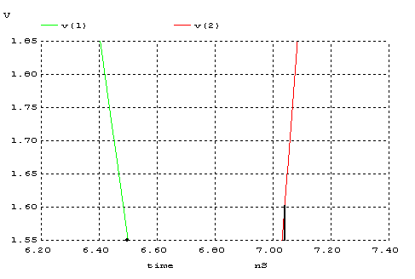
tf
%90
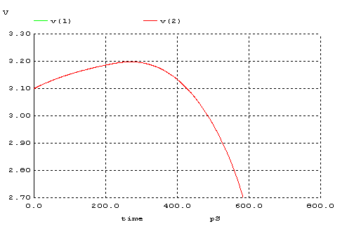
%10
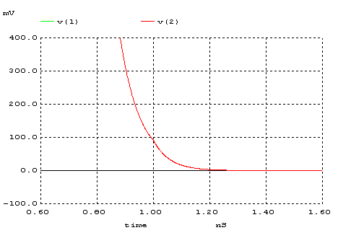
tr
%90
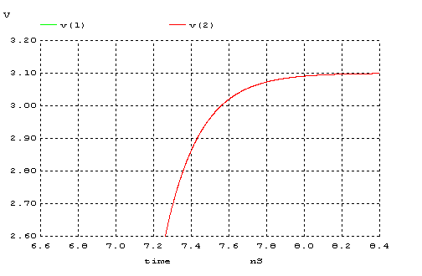
%10

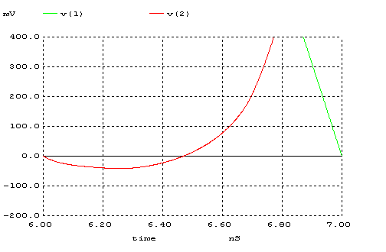

4.
*baran 4
.MODEL MOSN NMOS LEVEL=2 LD=0.15U TOX=200.0E-10
+ NSUB=5.36726E+15 VTO=0.743469 KP=8.00059E-05 GAMMA=0.543
+ PHI=0.6 U0=655.881 UEXP=0.157282 UCRIT=31443.8
+ DELTA=2.39824 VMAX=55260.9 XJ=0.25U LAMBDA=0.0367072
+ NFS=1E+12 NEFF=1.001 NSS=1E+11 TPG=1.0 RSH=70.00
+ CGDO=4.3E-10 CGSO=4.3E-10 CJ=0.0003 MJ=0.6585
+ CJSW=8.0E-10 MJSW=0.2402 PB=0.58

.MODEL MOSP PMOS LEVEL=2 LD=0.15U TOX=200.0E-10
+ NSUB=4.3318E+15 VTO=-0.738861 KP=2.70E-05 GAMMA=0.58
+ PHI=0.6 U0=261.977 UEXP=0.323932 UCRIT=65719.8
+ DELTA=1.79192 VMAX=25694 XJ=0.25U LAMBDA=0.0612279
+ NFS=1E+12 NEFF=1.001 NSS=1E+11 TPG=-1.0 RSH=120.6
+ CGDO=4.3E-10 CGSO=4.3E-10 CJ=0.0005 MJ=0.5052
+ CJSW=1.349E-10 MJSW=0.2417 PB=0.64

*eleman bağlantıları

VDD 3 0 DC 3.1
VIN 1 0 pulse (0 3.1 0 1n 1n 5n 10n)

M1 2 1 3 3 MOSP W=5.4u L=1.2u NRS=0.111 NRD=0.111
+ AD=16.2p PD=11.4u AS=16.2p PS=11.4u

M2 2 1 0 0 MOSN W=1.8u L=1.2u NRS=0.333 NRD=0.333
+ AD=6.5p PD=9.0u AS=6.5p PS=9.0u
.control
dc VIN 0 3.1 0.01
plot V(2) vs V(1)
.endc
.end

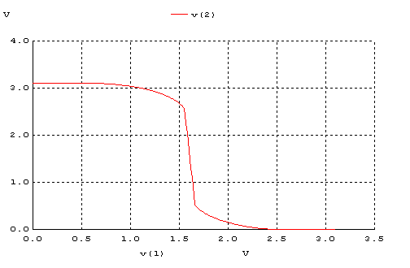
TRANSIENT ANALYSIS

*baran-transient 4
.MODEL MOSN NMOS LEVEL=2 LD=0.15U TOX=200.0E-10
+ NSUB=5.36726E+15 VTO=0.743469 KP=8.00059E-05 GAMMA=0.543
+ PHI=0.6 U0=655.881 UEXP=0.157282 UCRIT=31443.8
+ DELTA=2.39824 VMAX=55260.9 XJ=0.25U LAMBDA=0.0367072
+ NFS=1E+12 NEFF=1.001 NSS=1E+11 TPG=1.0 RSH=70.00
+ CGDO=4.3E-10 CGSO=4.3E-10 CJ=0.0003 MJ=0.6585
+ CJSW=8.0E-10 MJSW=0.2402 PB=0.58

.MODEL MOSP PMOS LEVEL=2 LD=0.15U TOX=200.0E-10
+ NSUB=4.3318E+15 VTO=-0.738861 KP=2.70E-05 GAMMA=0.58
+ PHI=0.6 U0=261.977 UEXP=0.323932 UCRIT=65719.8
+ DELTA=1.79192 VMAX=25694 XJ=0.25U LAMBDA=0.0612279
+ NFS=1E+12 NEFF=1.001 NSS=1E+11 TPG=-1.0 RSH=120.6
+ CGDO=4.3E-10 CGSO=4.3E-10 CJ=0.0005 MJ=0.5052
+ CJSW=1.349E-10 MJSW=0.2417 PB=0.64

*eleman bağlantıları

VDD 3 0 DC 3.1
VIN 1 0 pulse (0 3.1 0 1n 1n 5n 10n)

M1 2 1 3 3 MOSP W=5.4u L=1.2u NRS=0.111 NRD=0.111
+ AD=16.2p PD=11.4u AS=16.2p PS=11.4u

M2 2 1 0 0 MOSN W=1.8u L=1.2u NRS=0.333 NRD=0.333
+ AD=6.5p PD=9.0u AS=6.5p PS=9.0u
.control
tran 1p 20ns
plot V(2) V(1)
.endc
.end

